| **Mehran University of Engineering & Technology,**  **Jamshoro** | |  | **Subject** | | | |
| --- | --- | --- | --- | --- | --- | --- |
| **Web Technology** | | | |
| **Department of:**  **Bachelor of Science Computer Science** | | **Year** | **2nd** | **Semester** | **3rd** |
| **Roll No:** | **20BSCS043** | **Batch** | **20BSCS** | **Duration** | **3 Hours** |

## **PRACTICAL # 13**

## **TO DEVELOP THE LIVE WEBSITE (WEB HOSTING)**

# **LAB TASK**

**Task # 1:** Create your account on any free web server & place at least 3 pages website on it. Also place snapshots of your member’s area control panel & your website. Write link of your website as well.

**STEP 1:** Enter name from which you want to make the website.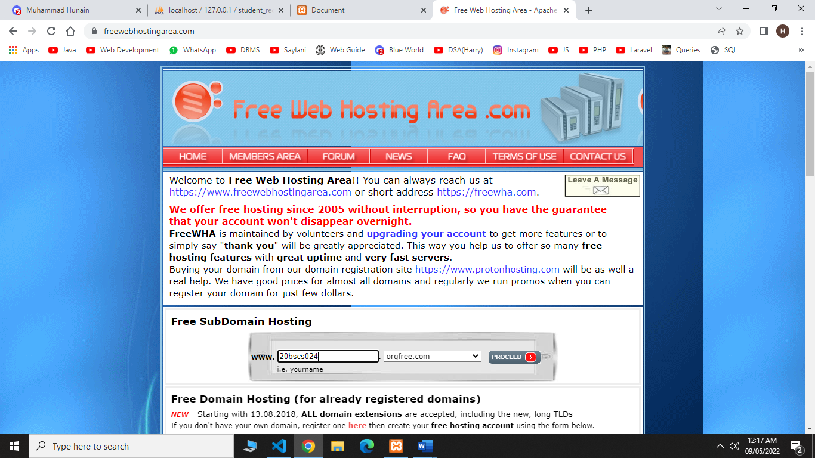

**STEP 2:** Enter your email and password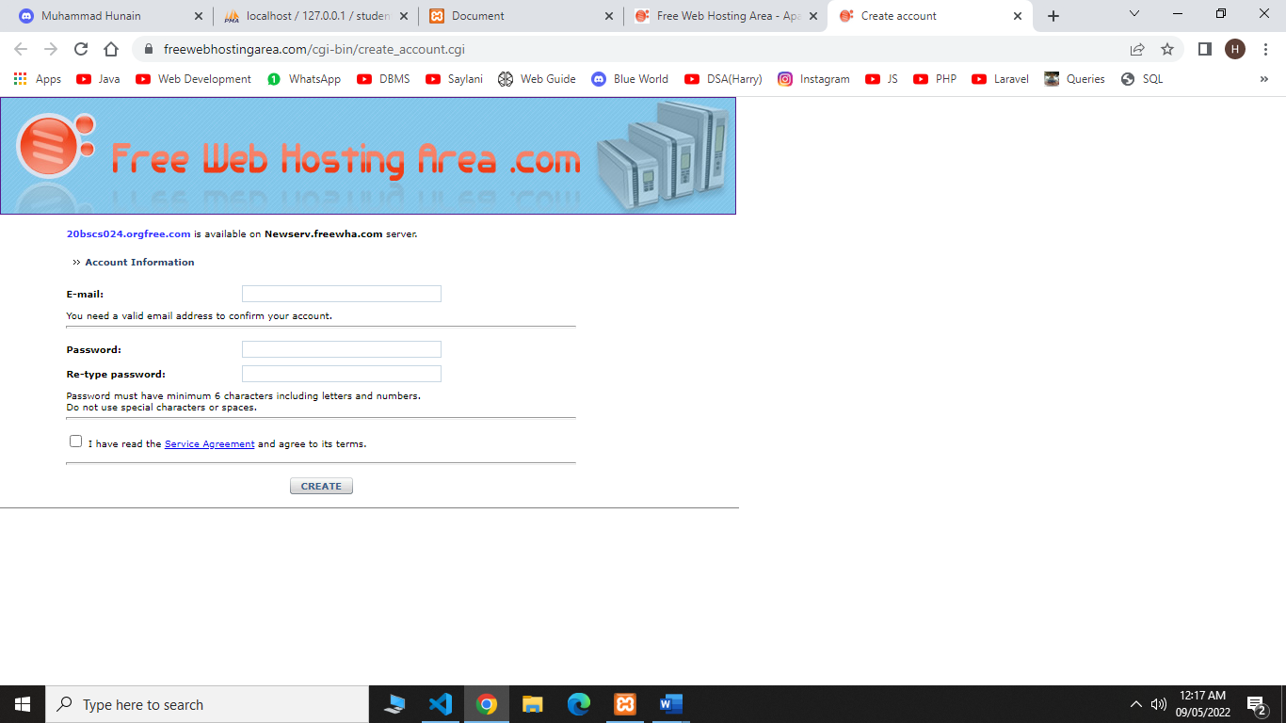

**STEP 3:** Save your user name and password

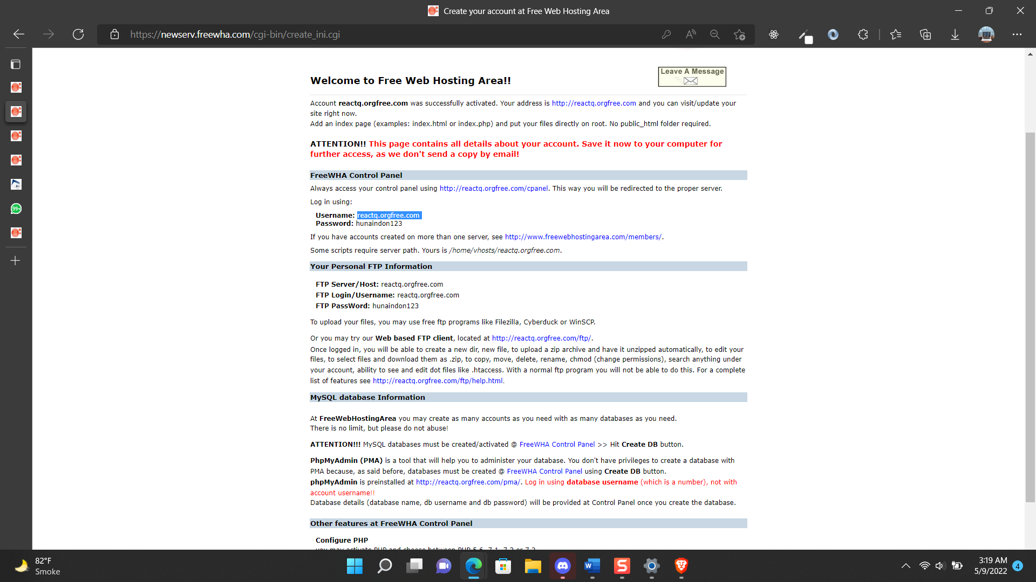

**STEP 4:** Now click on upload and upload your files.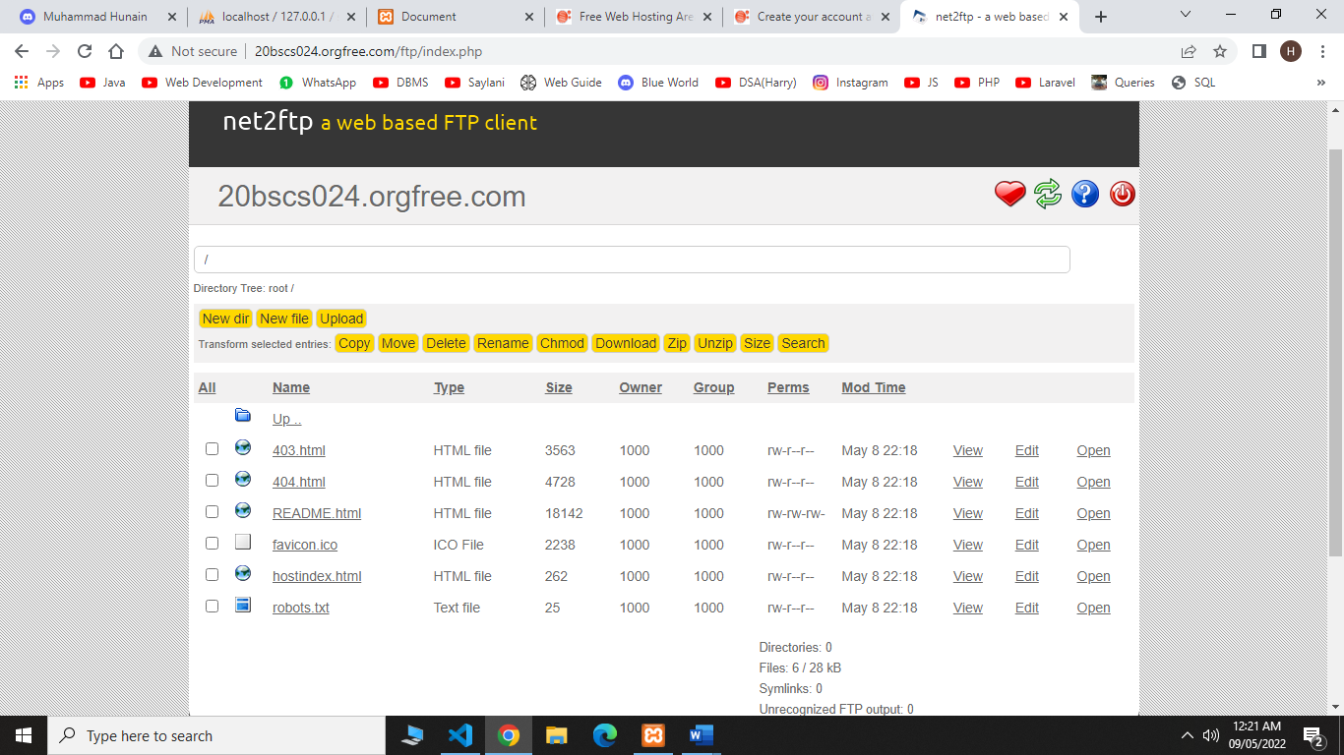

**MEMBER’S AREA CONTROL PANEL:**

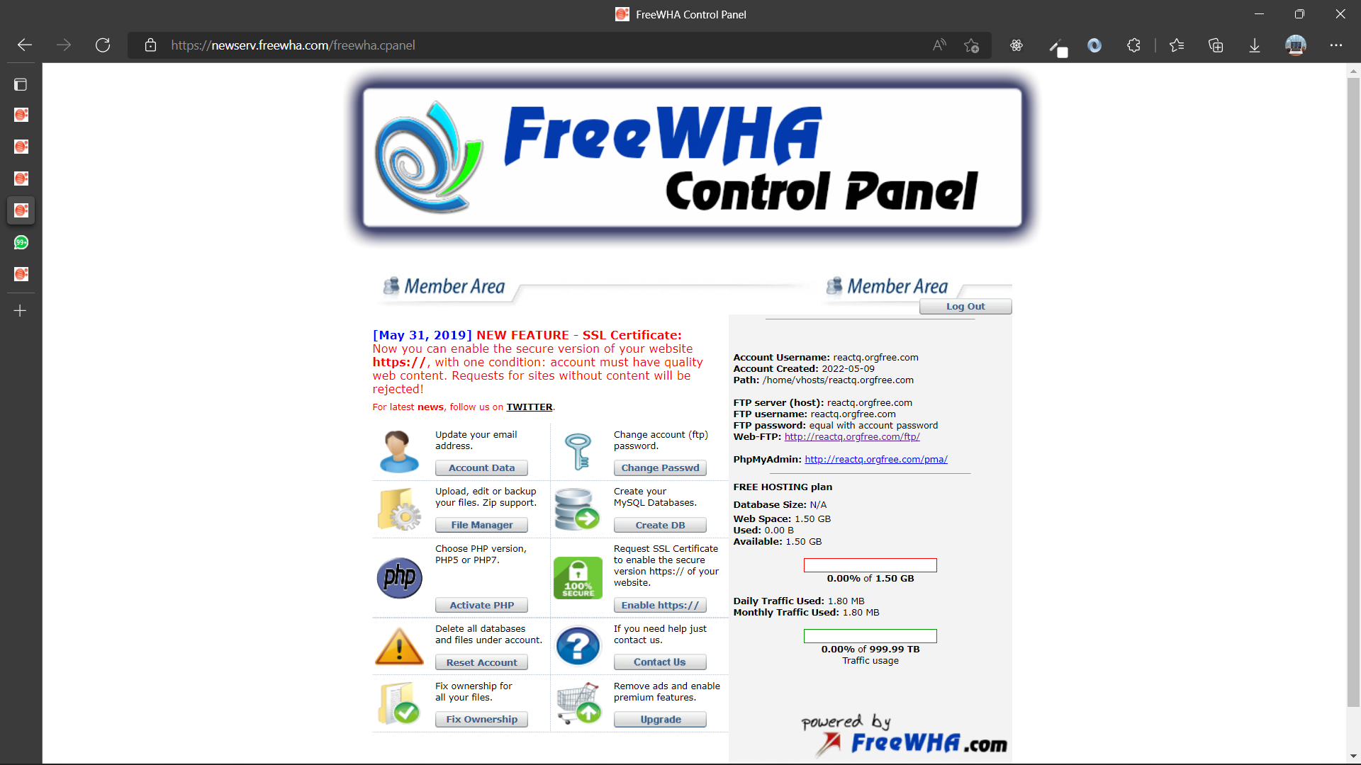



**WEBSITE SCREENSHOTS:**

**PAGE 1:**

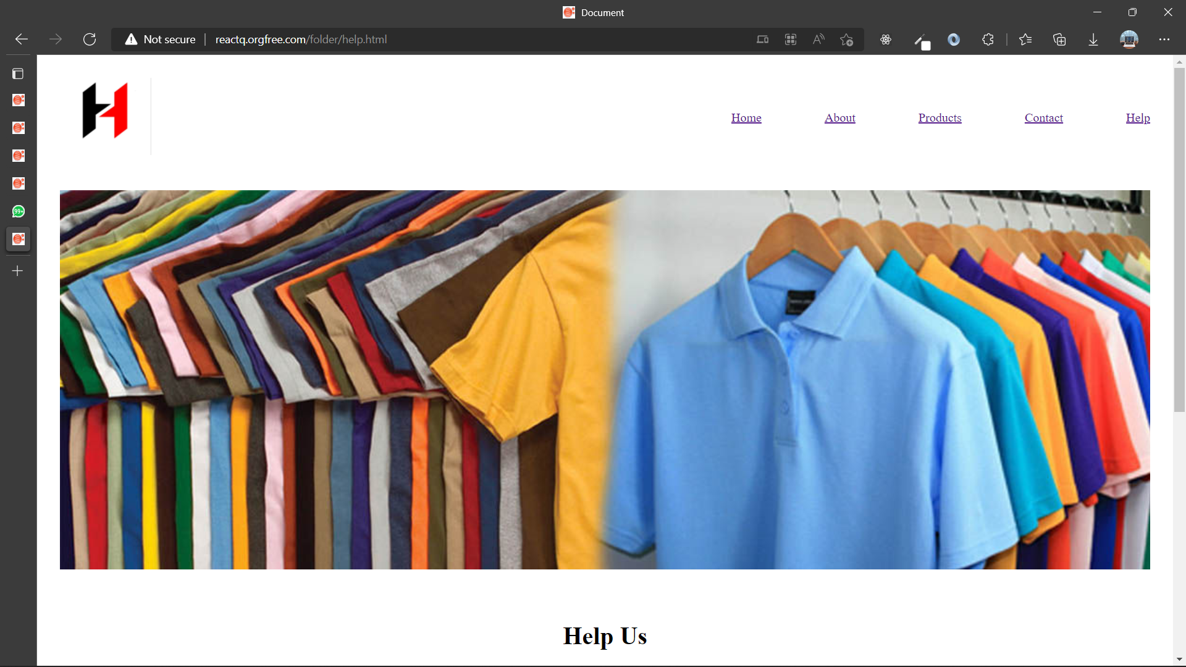

**PAGE 2:**

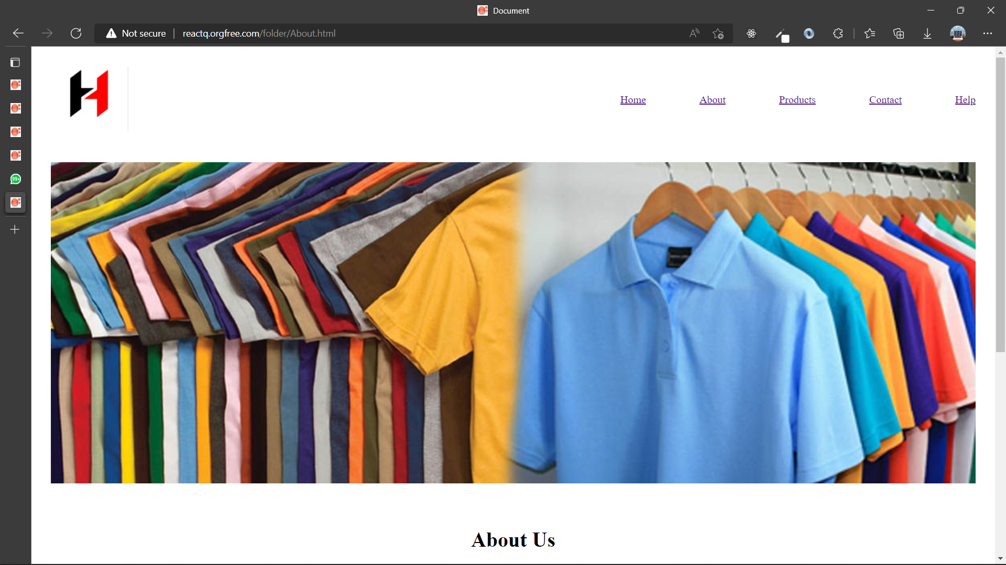

**PAGE 3:**

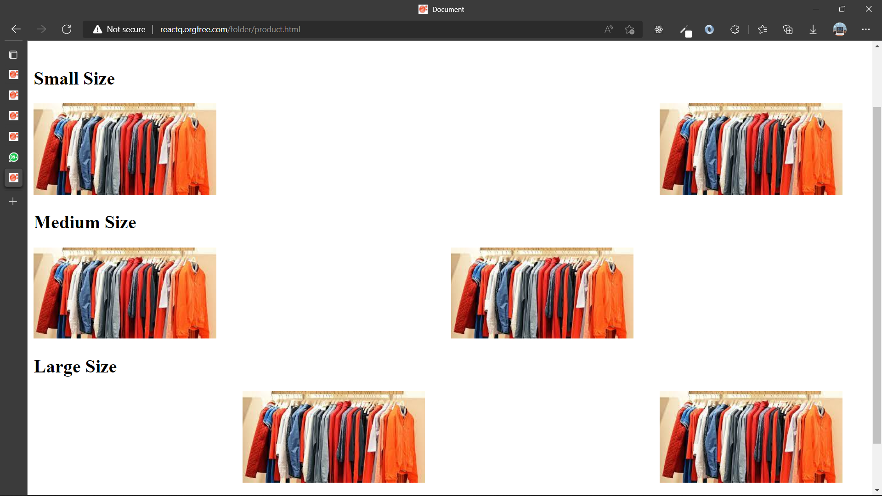

**PAGE 4:**

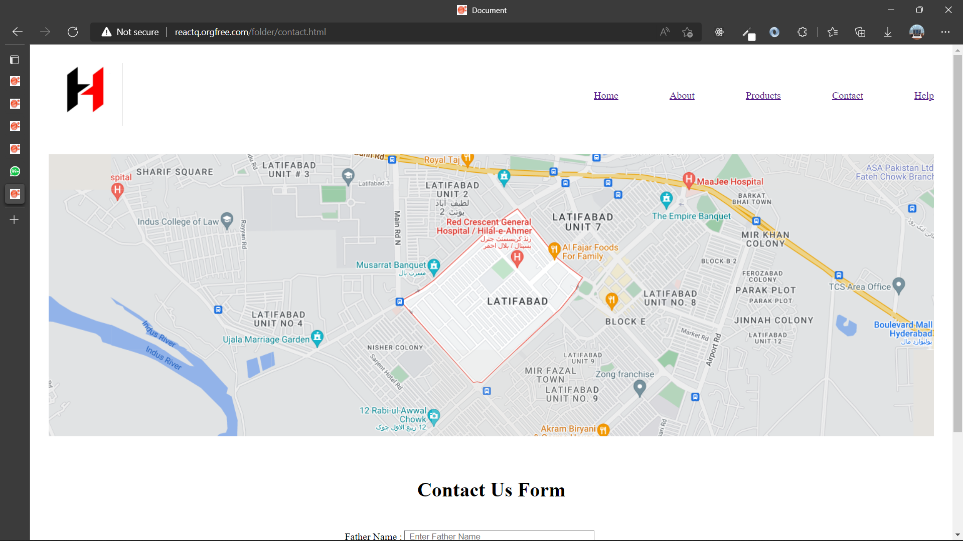

**PAGE 5:**

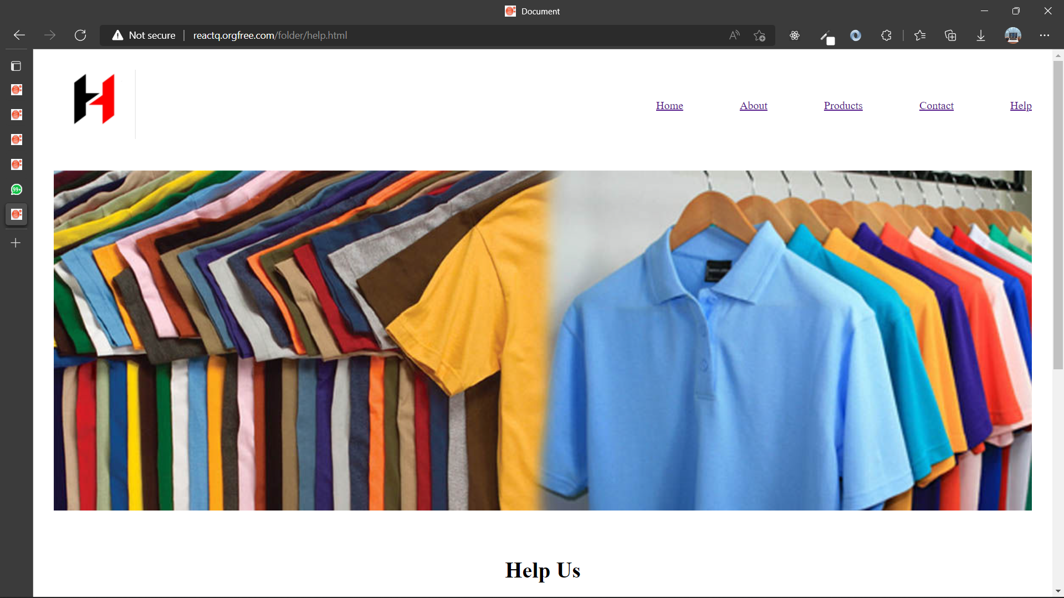

**LINKS:**

* [http:/reactq.orgfree.com/](http://20bscs024.orgfree.com/)folder/index.html